Intro
This is the first Animal Care Club News Letter of this academic year.
We have been back time has flown. The animals settled in quickly when back in the class, with Merlin looking very happy with all the attention.
CLUBS NOW RUN ON THE FOLLOWING DAYS.
MONDAY Yr 7
TUESDAY Yr 8
WEDNESDAY Yr 9
FRIDAY Yr 10
There have been a few changes to the group since my last newsletter. Sadly I had to say good bye to Marvina who was my first classroom pet. We think she was about 8 years old, which is pretty good for a fancy goldfish.
Fig 1. The late Marvina
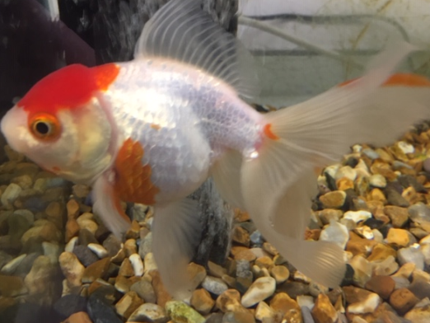
I have kept one of her offspring who will be called Maureen.
Leaf Insects
Further additions are the beautiful Leaf insects. These are also proving to be a big hit with the pupils.
I took delivery of three leaf insects. 2 at sub adult phase, and 1 at early nymph (Baby) stage.
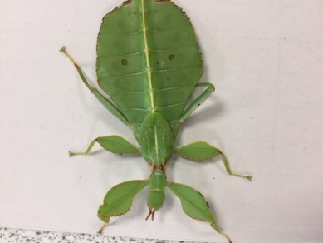
Wings!
Fig 2. Sub adult leaf insect (called Florence).
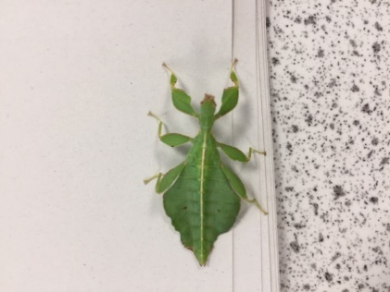
Fig 3. Nymph Leaf insect.
They have 6 stages from a nymph to adults. The third one has shed since getting them and is now in its adult phase. They truly are amazing, with long wings and a curious nature.
I am always amazed that just shedding can make them look so different.
Fig 4. Adult Leaf Insect Mary
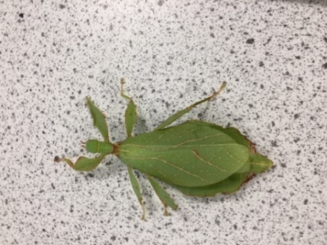
General Care
Like most Leaf insects they eat bramble, raspberry leaf and blackberry leaves.
They require no heat and just a little spray every other day. The moisture is important to allow shedding to be a success. Issues in shedding can be catastrophic with deformation, limb loss and being stuck in their shed.
Fingers crossed I can keep them well and they will start laying eggs through parthenogenesis.
I cannot wait for them to start laying eggs and to experience the hatching process.
Naming competition
I have so far managed to name two of the leaf insects Florence after Florence Nightingale.
Fig 5 Image of Florence Nightingale care of BBC Bitesize.
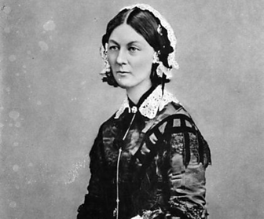
Florence has always been a hero of mine for her pioneering work in nursing regarding cleanliness. She was also the first person to research the therapeutic properties of animals in the sick and rehabilitating patient.
The second leaf insect is named after Mary Seacole, who I admire for her determination and grit to serve in the Crimean war, despite the obstacles she faced.
Fig 6 Portrait of Mary Seacole care of BBC Bitesize
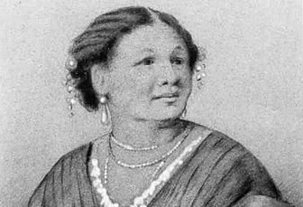
This leads me to a competition I would like to hold. I would like students to have the opportunity to name the youngest leaf insect.
The stick insect is a female so the name needs to suit.
I would like pupils to submit a short statement (no more than 200 word), stating which unsung historic hero they would like the leaf insect to be named after and why they are so amazing. ALL responses to jpetrie@worthinghigh.net no later than midday 23rd of October 2020.
The winner will be announced in the next half term.
Goodluck!

