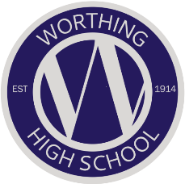

Covid-19 information – March 2021

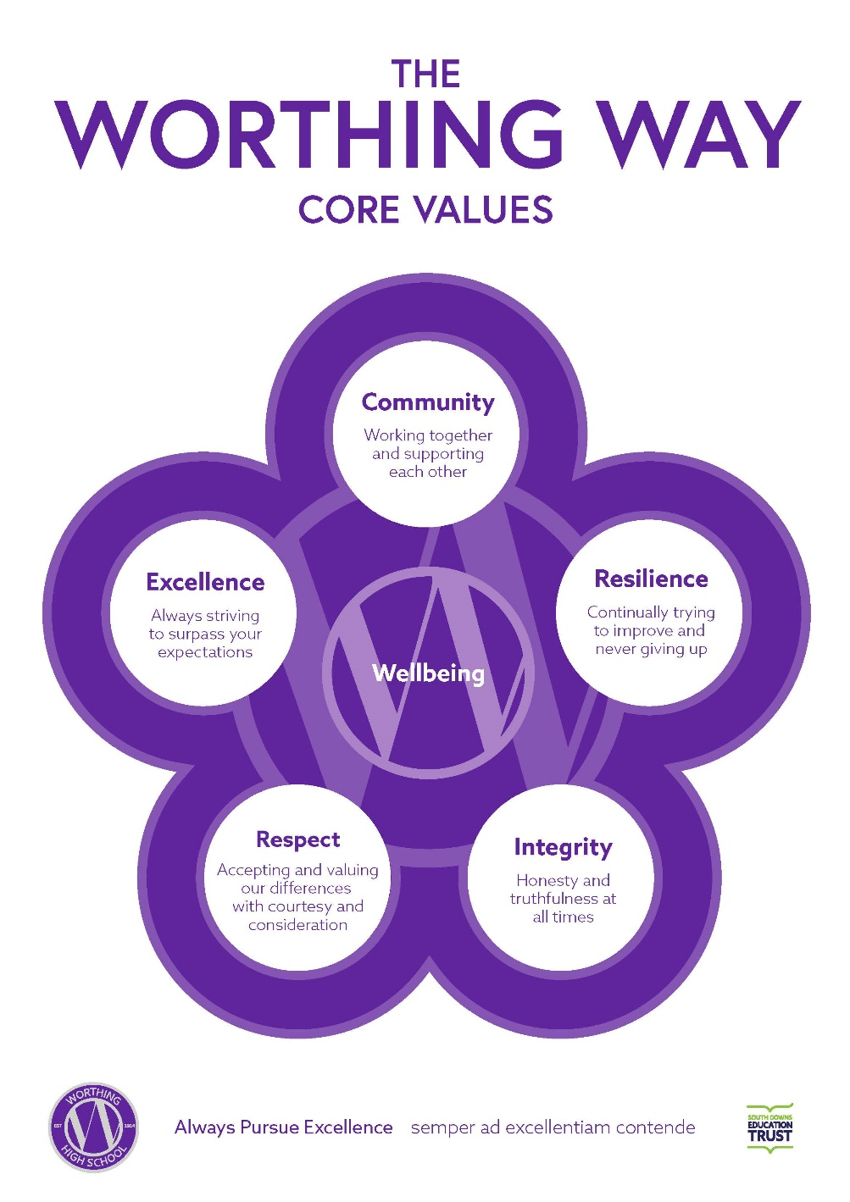

Parent/Carer Guide
(This supplements the school risk assessment)

Student return to school from 8 March 2021
LFT schedule for student return
Initial testing day prior to school return (this will apply to all year groups):
This is only applicable for students where parental consent has been given by Wednesday 3 March.
All students will receive an email with their appointment slot within the time slots detailed below. Students must arrive within this time slot. Please contact office@worthinghigh.net if you have any queries.
Arrival time | Community
9.50 – 10am | Broadwater 1
10.20 – 10.30am | Broadwater 2
11.15 – 11.25am | Heene 1
11.45 – 11.55am | Heene 2
12.20 – 12.30pm | Salvington 1
12.50 – 1.00pm | Salvington 2*
1.50pm – 2.00pm | Tarring 1
2.20 – 2.30pm | Tarring 2
3.05 – 3.15 | Students unable to make appointment time (pre-arranged)
*Year 9 Salvington 3 at 12.50am – 1.00pm
All students will be expected to participate in remote learning lessons when they are not travelling to and from school for their test.
All parents that have provided consent will receive an email with the students arrival time.
Please note that all students should adhere to current lockdown protocols when travelling to and from school. Students should enter the school through the Millennium Hall entrance wearing a face covering. They will be registered and then will be asked to confirm that they do not have Covid symptoms before a Lateral Flow test is carried out.
After the test is completed students will then leave the school and should immediately travel home to resume remote learning. If a positive test is recorded, parents will be notified and guidance will be provided. Negative test results will not be communicated.
Welcome assembly:
The next school day after their initial Lateral Flow test, students will attend a ‘Welcome Assembly’. They should arrive at school at their allocated time and then travel to the Millennium Hall for an 8.40am start, wearing face coverings as they enter the school premises.
Additional information
- Keyworker and vulnerable students will join the appropriate year group for testing from 5th March
- All keyworkers and vulnerable students will attend timetabled classrooms from Monday 8th March

- There will be an assembly from Monday 8th March for all year groups on their return to school:
    - Monday 8th March– Year 11
    - Tuesday 9th March– Year 10
    - Wednesday 10th March – Year 7
    - Thursday 11th March– Year 8
    - Friday 12th March – Year 9
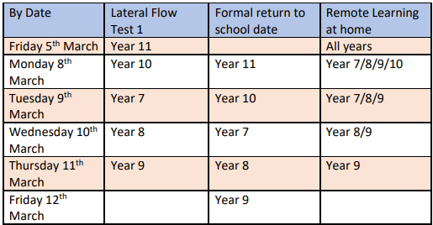
Social zones
- Social zones – will be in place until Easter at the earliest.
Year group | Zones | Poor weather provision | Food provision | Toilet Provision | Quiet workroom | Water Point
7 | F Block (inclusion), Millennium Hall, South Field, Quad and LRC | F Block, LRC and Millennium Hall | Millennium Hall servery hatch | Girls Side Millennium corridor | D4 | Millennium Hall lobby
8 | Drama Studio, Dance Studio, PE Canopy and MUGA | Drama Studio, Dance Studio and PE Canopy | SUD/TDA office (canopy end) | PE toilets | D7 | Fitness Suite lobby area
9 | B corridor (B3 ICT room) and Central Field | B Corridor | Canteen | Boys side Millennium corridor | B3 | Canteen
10 | Science block (Laptop trolley in C7) and Field (North Side) | Science block | Canteen | Technology toilets | C7 | Canteen
11 | North Playground, T1,2 and 3 and M Block | T1, 2 and 3 and M Block | North playground pod | A corridor | T1, T2 and T3 | Outside T4/T5

- Students will still be grouped in year group ‘bubbles’ for break and lunchtimes. Duty staff will ensure that students do not leave their zones unless accompanied by a member of staff.
- To facilitate the effective running of social zones, students can bring a packed lunch and hot food will be made available for all students to purchase in their social zones.
- Students that would normally attend inclusion classes at break and lunch will be allocated to a room in inclusion based on their year group.
- For the week commencing 8th March, the Millennium Hall will not be available at break and lunch times for year 7’s due to Lateral Flow Testing. The food servery point will still be available and Year 7’s will have access to D12 and D13 in addition to the LRC and South Field.
Timetabled lessons
- Students will be following their normal timetable to ensure they receive a broad and balanced curriculum.
- During the week commencing 8th March, students in the key worker and vulnerable categories will be following their normal timetable, re-joining their full year group as they return to school. Packed lunches will be required until their whole year group returns.
- Students will move between lessons using the one-way system to ensure minimal contact between students and will be encouraged to maintain social distances.
- All classrooms will be front facing where practicable. Where this is not practicable students will work in small groups and these will be consistent for future lessons in this subject area.
Remote learning
- There will be some students who may have to learn remotely at times due to having to isolate as they have tested positive, been in contact with a positive case, or be required to isolate as they are clinically extremely vulnerable.
- Teachers will post a copy of the resources from each lesson to the “files” section of Microsoft Teams in advance of each lesson. In many cases work will be posted weeks in advance, so it may not appear that work has been posted recently, but all resources are still available. Students should complete this work independently and either email it to their teachers or submit on Microsoft Teams.
- From the week commencing 15th March, Miss Schouppe (remote learning mentor) will be leading a remote registration period for students that are not able to attend school for reasons linked to coronavirus, or other exceptional circumstances. Students will be added to the Remote Learning Team on Microsoft Teams and should attend this registration period at 8:40 am. Miss Schouppe will also offer support to those students, where practicable, during their lessons throughout the day.
Homework
- Homework will resume for all students from their return to school.
- All homework will be set on Satchel One (Show My Homework).
School uniform and equipment
- Face coverings must be worn in communal areas in transit and as students enter classrooms. A member of staff may then provide students with the option to remove masks if it is appropriate to the learning objectives.
- Staff may be wearing clear face coverings in lessons to teach and support students.
- Students must attend in full school uniform except on days when they have a timetabled PE lesson.
- On days that students have PE, they must bring a waterproof jacket as they do not have the opportunity to get changed and we do not want students sat in wet clothes.
- If a student returns to school in incorrect uniform the tutor will contact parents and request that this is corrected in 48 hours. If this is not done, then the matter will be referred to the Progress Leader.
- Student clothes should be cleaned as regularly as practicable.
- Coats and jackets are permitted but must be stored in lockers or bags, they must not be carried around the building.
- Students must have full school equipment, please note this should include hand sanitiser where practicable and must include a reading book.
- Students will not be able to borrow equipment in lessons and will receive sanctions for not bringing in correct equipment.
- A reminder that extreme hair styles and colours are not permitted and only one small stud earing should be worn in each ear. Students not adhering to the uniform policy will receive school sanctions. Tutors will carry out weekly uniform checks with students.

Home Testing

- Once students have completed 3 Lateral Flow Tests in school we will issue a home test kit – which contains 7 tests.
- Twice weekly testing will then continue at home – during term time only and we will issue all parents/ carers and students with full guidance nearer the time.

Staggered entry and times of the day:
Timings for entry into school and dismissal (will remain as):
Year group | Entry time | Dismissal time
7 | 8.25-8.30am | 3.10-3.15pm
8 | 8.25-8.30am | 3.10-3.15pm
9 | 8.30-8.35am | 3.10-3.15pm
10 | 8.30-8.35am | 3.15-3.20pm
11 | 8.35-8.40am | 3.15-3.20pm

Students can continue to enter the school from 8am and should report to their social areas:
Year group | Social zone from 8am until entry time | Movement to tutor time:
7 | LRC | 8.25-8.30am
8 | PE Area (covered canopy) | 8.25-8.30am
9 | B Corridor | 8.30-8.35am
10 | Science Block | 8.30-8.35am
11 | B and E Corridor | 8.35-8.40am

Please note the school day timings will continue as follows:
Event | Time
Registration/Assembly | 8.30-8.55am
Period 1 | 9.00am
Period 2 | 10.05am
Break | 11.05-11.20am
Period 3 | 11.25am
Period 4 | 12.30pm
Lunch | 1.30 – 2.00pm (shorter by 10 minutes)
Period 5 | 2.05pm
Student briefing period | 3.05-3.20pm

Year 10 SRE
Will now be moved to Thursday April 22nd to enable students to settle back into school and for staff to be able to provide relevant information related to their academic progress both through remote learning and on their return to school.

ARD (Academic Review Day)
Will take place on Thursday 1st April 2021. This will consist of 10 minute remote interviews between tutors and students from their tutor group. This will be to discuss students return, check on their welfare and assist with any concerns that they may have. This will be completed for all students remotely via Teams.
Students will be set ‘off-screen’ tasks for the day as we have been for Curriculum Days.

After school clubs/provision
Will begin to operate from Monday 15th March, this includes period 0 and period 6.

