Well-being
I hope you had a go and enjoyed some of the activities linked last week. This week’s weekly well-being activities are linked below. Every week we encourage that your child choose at least 2 activities to complete over the course of the week. Time before lesson routines, as a break from lesson content or at the end of the typical school day (3.15) are all possible times to take up one of the activities. This week’s well-being options are:
- Be active–Dance. Ways you could use this time to dance:-
- Choose a song to choreograph a dance to. Plan it out on paper, listen to the beats or simply work it out as you go along.
- Use a dance tutorial, if you can avoid an ipad and use a television that would be better. There is a fun Fortnite dance tutorial featured below.
- Simply dance like no one is watching alone or get your family involved.
https://www.youtube.com/watch?v=MnpxQr3KXNw&feature=emb_logo
Aim to do this for at least half an hour
- Create – Comic Strip
Comic strip or comic books can be a fun way to tell a story and express how you are feeling. Why not make one about lock down or how you are feeling right now? or something funny that has happened
- Decide on your story.
- Design your characters.
- Plot the scenes.
- Get creative.
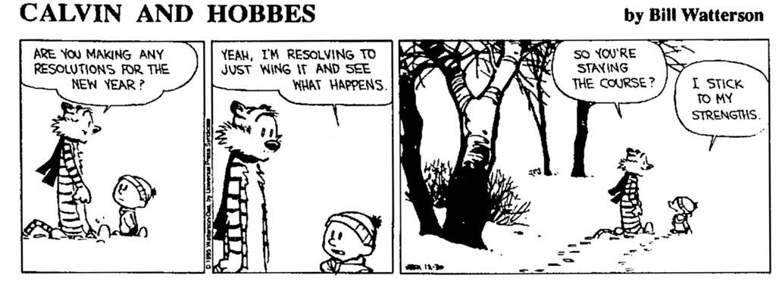

- Take notice – take a virtual tour of the Louvre museum in Paris. Follow the link and pick an exhibit. https://www.louvre.fr/en/visites-en-ligne
- Stay connected – set up a family video call quiz
- Give – Life skills: Tidy your bedroom
- Pick everything up off the floor.
- Put all clean clothes away.
- Put all dirty clothes in the Laundry.
- De-clutter surfaces.
- Empty the bin.

