ONCE A HISTORIAN, ALWAYS A HISTORIAN!


The History department would love for you to continue to stay cognitively engaged over the coming weeks and months, despite the cancellation of this year’s exams. The following are suggestions, they are not compulsory, but we would love for you to engage in any that you find interesting.
 | 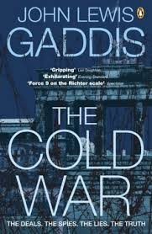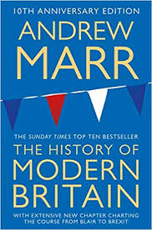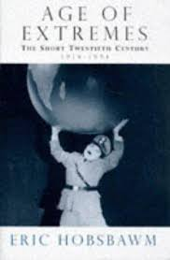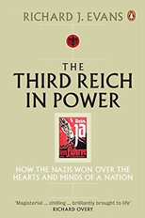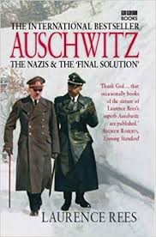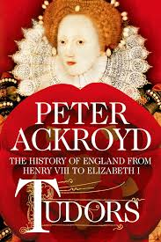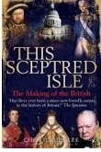

 | 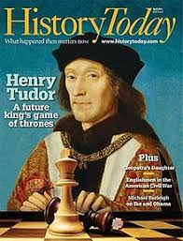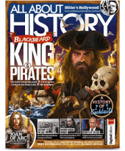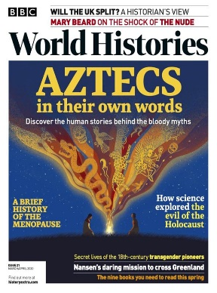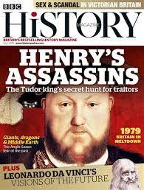

 | 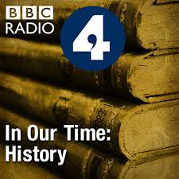 | You’re dead to me podcast  Voices of the First World War  The Ratline  Tunnel 29  Dan Snow’s History Hit  Versus History

 | https://www.bbc.co.uk/programmes/genres/factual/history  https://historyasm.blogspot.com/  https://www.history.com/news  https://www.historyextra.com/topics/  https://www.historytoday.com/best-articles-2017  https://www.youtube.com/channel/UC22BdTgxefuvUivrjesETjg

