Core Knowledge

Add a picture of your final project here once complete.

Remember:
Draw in Pencil and write in pen.
Have your OCR text book readily available.

YOU MUST ALWAYS FOLLOW THE HEALTH AND SAFETY RULES WHEN IN THE WORKSHOP.
Test your knowledge of each section using MOODLE and the past exam papers

Name:
End of Year Target Level:

Technology Group:
Date:

Section A: Learning Objectives-
Progress Chart (Green/Amber/Red)

You will have developed a knowledge and understanding of:
One-off, batch and high-volume production systems
Modular/ cell production systems
Just-in-time manufacture
Bought-in parts and components, standardised parts
The implications of these industrial production processes/ procedures

Production Methods
Manufacturing systems involve processes that are one-off, batch and high volume. When selecting a manufacturing system you need to consider:
Type of product | Demand | Capital | Premises | Tooling | Labour skill
(Labours products demand capital tooling premises)
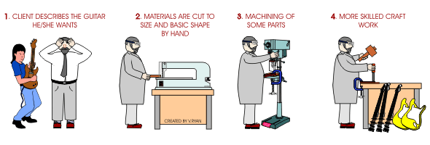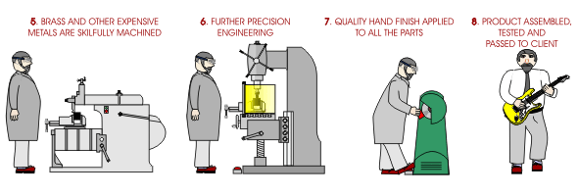
One-off production is:
Some one-off products may include:
Three examples where one-off production may be used are:
KEY POINTS
Type of product | Demand | Capital | Premises | Tooling | Labour skill

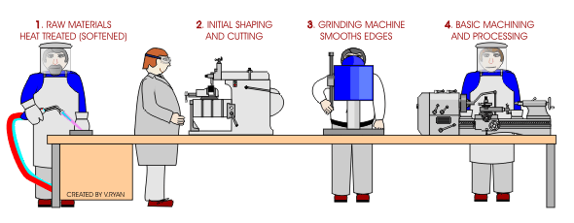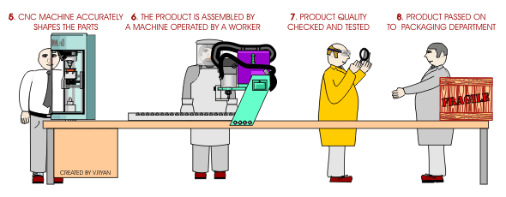
Batch production is
Some batch produced products may include:
Three examples where batch may be used are:
KEY POINTS
Type of product | Demand | Capital | Premises | Tooling | Labour skill

High volume production is:
Some high-volume produced products may include:
Three examples where high-volume production may be used are:
KEY POINTS
Type of product | Demand | Capital | Premises | Tooling | Labour skill

Within High volume production a number of systems can be used including:

Continuous-flow production which is
In-line production systems which are
Some examples of products made by high volume production methods are

Modular or Cell production systems

These systems use a number of production cells or modules that are

Cells or modules usually consist of
Batch and queue manufacturing systems are
KEY POINTS

Just-in-time manufacture (JIT)
The JIT system is sometimes referred to as
JIT manufacture is
KEY POINTS
Computerised stock control systems ensure that production is continuous.
Wastage is reduced in terms of
The drawbacks of the system include:

Bought-in parts and components
KEY POINTS
Standardised parts
Some examples are
KEY POINTS

Can you discuss the pros/ cons of all the theory in this section? Are you aware of how they relate to each other? Can you compare the pros/ cons of different manufacturing methods?

Section B: Learning Objectives-
Progress Chart (Green/Amber/Red)

You will have developed a knowledge and understanding of:
CAD/CAM as used in industry/commerce
Testing, modelling and rapid prototyping
Stock control, monitoring and purchasing logistics in industry
High-volume production and automation
The implications of the use of digital technology

CAD and CAM
Global communication systems have
CAD was introduced and initially used as a
Vector based systems describe geometries that can be converted into
The development of computers and (CNC) machines are the single most significant contribution to the increase in manufacturing productivity.
Ideas can be

CAD systems could include | CAM systems could include
Acronyms
CADD -
CAA -
CAAD -
CAE -
CAPP -
CIM -
Testing, modelling and rapid prototyping
Computers can be used to
Finite Element Analysis can be used to
CAA software can be used to
Fluid Dynamic software is used for
Computer are used for 2D and 3D modelling because

Computer simulations are used because
Rapid Prototyping
Types of rapid prototype systems include
Laminated object manufacture | Stereo Lithography | Laser Sintering | 3D printing
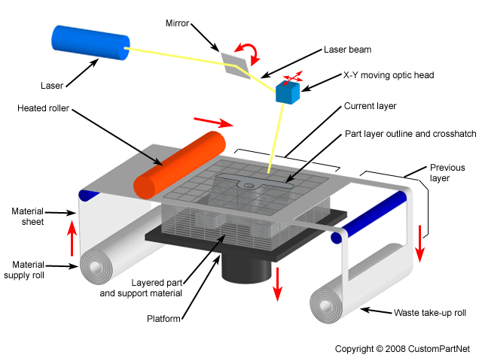 | 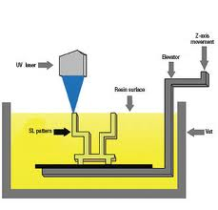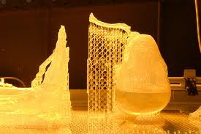 | 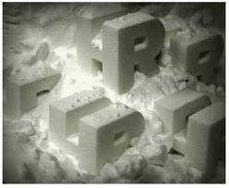 | 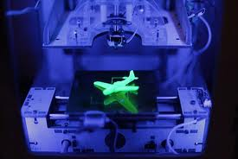

Stock control, monitoring and purchasing logistics
The three groups stock is usually classified as are:
1.
2.
3.
Stock control enables
Stock control used to rely on
Computerised systems, including the use of barcodes and other digital recognition processes to monitor stock, have made the process quicker. Links are made with
The purchasing and logistics departments will
‘Buffer’ stock is
Two types of sensor that may be used are:
1.
2.

Electronic Data Interchange (EDI)
EDI is
It is used because
The benefits of EDI are

The benefits of computerised stock control are:
1
2
3
4
5
6
7
8
9
The drawbacks of computerised stock control are:
1
2
3
4
5
6

High-volume production and automation
Computer Integrated Manufacture (CIM) is used by
It is an integrated system that includes CAPP, , and CNC machinery, and also controls Automatically guided vehicles (AGVs) in an Automatic storage and retrieval systems (ASRS). CADCAM is central to the system.
Process planning software is used to
Software is also used to

CNC machine are used for a wide range of operations including

Computer systems can be used to check for quality control. This could include

The benefits of automated systems are:
1
2
3
4
5
6
The drawbacks of automated systems are:
1
2
3
4
5

Robots have a key role in automated systems. They are used for

Section C: Learning Objectives-
Progress Chart (Green/Amber/Red)

You will have developed a knowledge and understanding of:
The role of marketing, including assessing consumer needs, product
development, pricing, promotion and distribution
Advertising

Marketing
Marketing is
New product development can include:

Market Research
Sometime called ‘in-bound marketing’, market research involves finding out and analysing information about:
1.
2.
3.
4.
5.
6.
Primary research is
Some examples are
Secondary research is
Some examples are

The next stage is sometimes referred as ‘out-bound marketing’, this includes

A company needs to decide on the marketing mix (often known as the four P’s although some companies also include people and processes).

Marketing Mix
The 4Ps are
A product is examined on three levels:
1.
2.
3.
The quality of a product depends on

Price depends on
Methods of pricing include

Promotion is
Methods of promotion include

AIDA is used with promotion. It is an acronym for

Place is
There are four main channels of distribution:
1.
2.
3.
4.
Functions of distribution channels include:

Advertising
Advertising is
Medium | Advantages | Limitations | Cost issues
Television

Radio

Newspapers and magazines

Direct mail

Billboards

Online

Adverts are controlled by
Their job is to

Can you discuss the best method of advertising for different target markets? Can you discuss how manufacturers meet consumer needs in a rapidly changing product market? Can you discuss the implications to the manufacturer of market competition?

Section D: Learning Objectives-
Progress Chart (Green/Amber/Red)

You will have developed a knowledge and understanding of:
Trade description and sales of goods
BSI standards applied to products/systems
Labelling
The implications of intellectual property
Regulations

Trade description and sale of goods
The two acts that are primarily to do with the sale of good are
The sales of goods act 1979 protects consumers and helps them to
Key features of the sales of goods act include:
1.
2.
3.
4.
5.
6.
7.

The trade description act makes it an offence for a trader to
Key features of the trade descriptions act include:
1.
2.
3.
4.
5.

Product Labelling
Product labelling is covered under the
The food labelling regulations 1996 act relates to labelling food. Information that should be included on food
packaging is:

Video films have to be labelled with a
The BS 2747 code of practice for textile care labelling recommends

Examples of quality and safety assurance labelling
The CE mark refers to
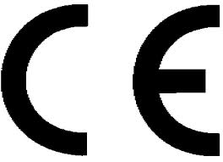
Write a definition for each symbol.

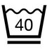
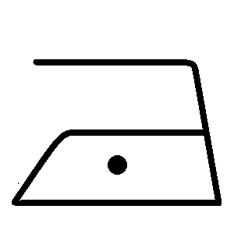




Draw another BSI safety label that can be found on electrical products such as light fittings, fires and cookers.

Key Points:
1.
2.
3.
A standard is an agreed way of doing something. There are five types of British Standard: specifications, methods, guides, vocabularies and codes of practice.
Standards help a company to:
1.
2.
3.

Intellectual Property
Intellectual property (IP) refers to
It allows you to
The main types are

Design rights –
Key points

Registered designs-
Key points

Patents-
Key points
It can include:
It can’t be awarded for:

Trademarks-
Key points

Copyright-
Key points

Can you explain how legislation can protect consumers of domestic electric products? Can you discuss the pros/cons of legislation to protect IP?

Section E: Learning Objectives-
Progress Chart (Green/Amber/Red)

You will have developed a knowledge and understanding of:
Control of substances hazardous to health (COSHH) legislation
Protection of the worker/ operator
Protection of the user/ customer
Protection of the environment
Risk assessment
The regulatory and legislative framework related to materials and
equipment using Health and Safety at Work (HASAW)

Health and Safety at Work Act
HASAW states that
The management of Health and Safety and Work Regulations 1999 give guidance on
The two jobs that are responsible for enforcing the existing health and safety law are:
1.
2.
Key points of the Health and Safety at work act 1974
Employers duties include | Employees duties include

Control of substances hazardous to health regulations 2002 (COSHH)
Consequences for an employee would include
Consequences for an employer would include
Implementing COSHH can lead to:
1.
2.
Hazardous substances can include:
1.
2.
3.
Three things not covered are
COSHH regulations only apply to products if they have a

The eight steps to comply with COSHH are:
1.
2.
3.
4.
5.
6.
7.
8.

Other important health and safety regulations
Four other regulations you should know are:
1.
2.
3.
4.

Risk assessment
Where there are five or more employees,

HSE guidance describes five steps to carry out a risk assessment. The steps are:
1.

2.

3.

4.

5.

Can you discuss how legislation can be used to protect workers/ operators? Can you discuss the issues to be considered by manufacturers when implementing a risk assessment?

Section F: Learning Objectives-
Progress Chart (Green/Amber/Red)

You will have developed a knowledge and understanding of:
Issues relating to global sustainable development
The energy needs during the life of a product or system - LCA
The terms ‘availability’, ‘conservation’ and ‘pollution’ relating to energy
Recycling and green issues in product and system design

Issues relating to sustainable development
The Brundtland Commissions definition of sustainable development is

The field of sustainable development can be broken into three parts:
1.
2.
3.

Why sustainable design is important?
If everyone lived like we do in the UK we would need 3 planets. Five other facts to think about are
1.

2.

3.

4.

5.

6.
A primary footprint is
A secondary footprint is

So what can we do about it?
We need to consider the
We can also think about the 6 Rs:
1.
2.
3.
4.
5.
6.
The energy needs during the life of a product or system.
Life-cycle assessment is
Life-cycle inventory (LCI) is
The six stages in terms of energy needs in the life of a product or system are:
Inputs | Stage | Outputs
 | Acquisition of raw materials-
 | Transporting raw materials-
 | Processing raw materials-
 | Manufacturing the product-
 | Using the product-
 | Disposal-

Eco-labelling
The scheme is designed to:
1.
2.
3.
4.
5.
The symbol for the European eco-label is

Energy – availability, conservation and pollution
Fossil fuels account for per cent of global energy use. It is estimated that we have about
years of coal
years of oil
years of gas
Burning fossil fuels creates energy but also creates

Within the UK electricity is the main source of power. More renewable source are being used because

Types of energy
Method | Description | Advantages | Disadvantages
Nuclear

Gas/Coal/Oil

Hydro-electric

Wind

Solar photovoltaic

Tidal Barrages

Wave

Geothermal

Biomass

Conservation and pollution
Society can make a contribution by:
1.
2.
3.
4.
5.
6.

The greenhouse effect
The Earth is surrounded by a layer of gases including
This layer allows the sun’s rays to penetrate.

Around 30 per cent is deflected by ice caps and cloud, but the majority of rays are absorbed by the earth and oceans and are released back as infrared radiation.

The layer of gasses prevents all of the radiation leaving and traps enough to heat the lower the atmosphere. Without this layer temperatures would be 30 degrees C cooler. The blanket is becoming thicker and creating global warming because of

Electricity production also causes

Acid Rain
Coal-fired power stations emit
Regulations have been introduced to limit the emissions because there have been direct links to the destruction of plant life and pollution of rivers.
Acid deposition is
Wet deposition is
Dry deposition is
Flue gas desulphurisation (FGD) is one method used to remove pollutants. It is a ‘wet scrubber’ system.
It works by

Fine particle pollution is

Recycling and green issues
Recycling prevents some environmental issues but

Key term- the waste hierarchy
1.
2.
3.
Key fact about recycling materials
Material | Facts
Aluminium and steel
Glass
Paper and cardboard
Textiles
Plastic | PETs Have PVC Leggins incase they PP PS there are OTHER plastics

Discuss the implication of changing the materials used for food and drinks cans.
Discuss the implications of using non-sustainable resources in disposable products.
Discuss the implications for the design of packaging to enable a reduction in the volume of disposable waste.
Discuss the implications of using recycled materials in the manufacture of products.
Discuss the implications of the increased availability and use of ‘throw-away products’.

Section G: Learning Objectives-
Progress Chart (Green/Amber/Red)

You will have developed a knowledge and understanding of:
Environmental, moral, economic and social issue in product design
The effect of fashion, trends, taste and style
The effect of new technological developments
Ethnic and cultural influences within design and manufacture

All that glistens is not gold
Key terms
Ethical-
Ethnic-

We shouldn’t just stop buying non-ethical products because
Non-ethical product could include

What can you do to make a difference?
1.
2.
3.
4.
5.
6.

What should you know about sustainable design?

The 6R’s

Section H: Learning Objectives-
You will have developed a knowledge and understanding of:
Progress Chart (Green/Amber/Red)

Develop a critical awareness of designed objects in terms such as colour,
form, shape, taste, texture and surface finish.
Consider the way aesthetic aspects influence appearance, contrast,
composition, harmony/disharmony

Aesthetics in its widest interpretation is involved with
Aesthetic failure is
‘Form follows function’ refers to a product that has been
Shape is
Form is
Taste is

Define the following Aesthetic features.
Visual | Hearing | Taste | Touch | Smell
Pattern | Loudness | Sweetness | Texture | Strength
Balance | Pitch | Sourness | Comfort | Pleasant
Composition | Melody | Texture | Temperature | Unpleasant
Rhythm
Harmony
Contrast

Colour associations in product design
Red
Blue
Yellow
Green
Brown
Orange
Pink
Purple
Black
Grey
White

Section J: Learning Objectives-
Progress Chart (Green/Amber/Red)

You will have developed a knowledge and understanding of:
Ergonomics when designing products
Applying anthropometric data when designing

Copy Stephen Pheasant’s key term

Ergonomics is

Anthropometrics is
The three principles for applying anthropometric data are:
1.
2.
3.
The percentiles that we usually consider when designing are
The 50th percentile is

Using human factors in designing
When designing a hand held tool we need to consider:

A dynamic dimension is

Using and obtaining ergonomic and anthropometric data
We use this data because

Inclusive design
Inclusive design is
It is important because

Can you describe with sketches and notes how anthropometric data and ergonomics could be taken into consideration when designing a product?

Section K: Learning Objectives-
Progress Chart (Green/Amber/Red)

You will have developed a knowledge and understanding of:
How to use technical data

The benefits of electronic technical data are
Technical data can be used to

Section L: Learning Objectives-
Progress Chart (Green/Amber/Red)

You will have developed a knowledge and understanding of:
Tests to identify characteristics/ properties of materials

Common tests include tests for

Destructive testing
Type | Description | Diagram
Tensile testing: using a ‘tensometer’
Brinell hardness testing
Vickers pyramid hardness test
Izod impact test for toughness/ brittleness
British Standards test for abrasion
Sensory testing of food

Non-destructive testing
Type | Description | Diagram
X-rays
Ultrasonics
The Shore scleroscope

Section M: Learning Objectives-
Progress Chart (Green/Amber/Red)

You will have developed a knowledge and understanding of:
Quality control
Quality assurance
Total quality management

Quality control
The expectation and requirements of the customer may include

It is important that a company meets these needs and expectations because

Total quality management
TQM is

TQM relies on

Quality assurance
Quality assurance is

Quality assurance is the responsibility of

Quality control
Quality control is

Quality control checks could include:

Section G: Learning Objectives-
Progress Chart (Green/Amber/Red)

You will have developed a knowledge and understanding of:
Up-to-date materials and their application in product design

Smart materials are

Modern materials are

Smart material – Textile examples

Smart material – Food examples

Materials | Description and properties
Polymorph

Shape memory alloys

Piezoelectric materials

Chromic materials |  | Photochromic-  Thermochromic-  Electrochromic-  Piezochromic-  Solvatochromic-

Tools and equipment | Health and Safety issues | The projects that I used this tool in. | Date and authorised signature
General Workshop safety
Coping saw

Hand Drill

Files

Rasps

Vacuum former

Fretsaw

Pillar Drill

Student voice

Vocabulary/ Spellings

Self assessment

