In 2015, Rick Riordan embarked on creating a fantastical world for millions to escape to - The Magnus Chase trilogy. It is an excellent series featuring the Sword of Summer, the Hammer of Thor and The Ship of the Dead. Starring Magnus Chase, Samirah Al-Abbas, Hearthstone, Blitzen and one other character that shall not be discussed in this introduction because - spoilers! Do you enjoy learning about mythologies? Specifically, Norse mythologies? Then this is the series for you! The story follows our characters as they explore the Nine Ancient Norse Worlds and the downfall of Magnus’ life after his death. He travels the realms learning magic, meeting gods, giants and monsters, and attacking some of them.
It’s time to Go-A-Viking!
*Warning* The following content will contain spoilers.
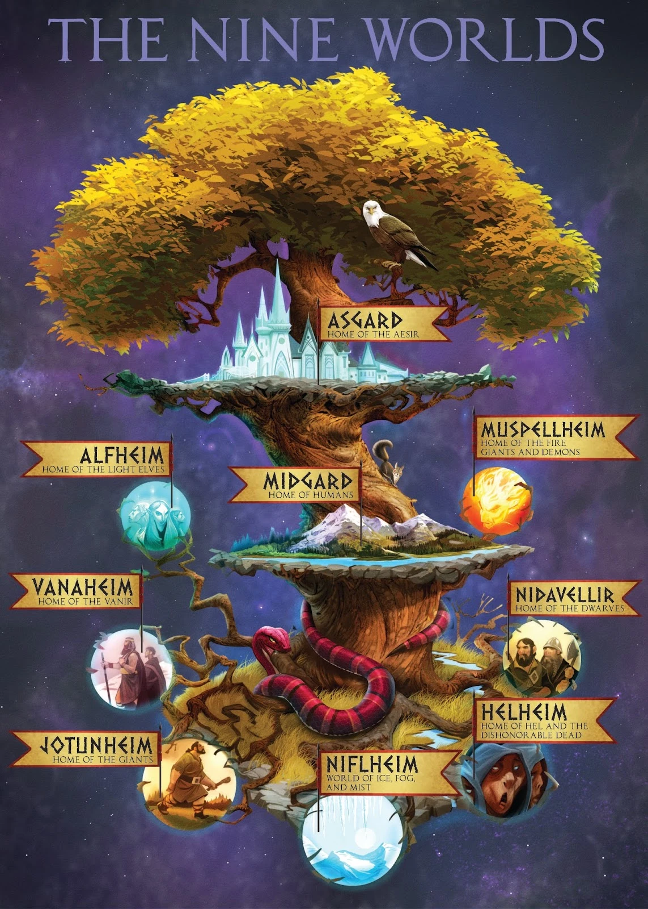
Why are there Nine Worlds?
There are nine realms in the story of Magnus Chase, all connected by the branches of Yggdrasil.
From the realm of war - Asgard to the realm of the dead - Helheim.
- Vanaheim (realm of nature gods)
- Alfheim (realm of elves)
- Midheim (our realm)
- Nidavellir (realm of dwarfs)
- Jotunheim (realm of giants)
- Muspelheim (realm of fire)
- Niflheim (realm of ice)
All of them, however, bear a strange resemblance to Boston. Personally, I think the setting of Magnus Chase is cleverly done, with many places and realms for our protagonists to explore. On the other hand, though, the whole, ‘Boston is the centre of the universe so all the realms look like it' thing is a bit odd and almost negates the idea of the diversity of the realms. Also, of course it’s an American city that's the centre of the universe. #TeamUK
The Characters
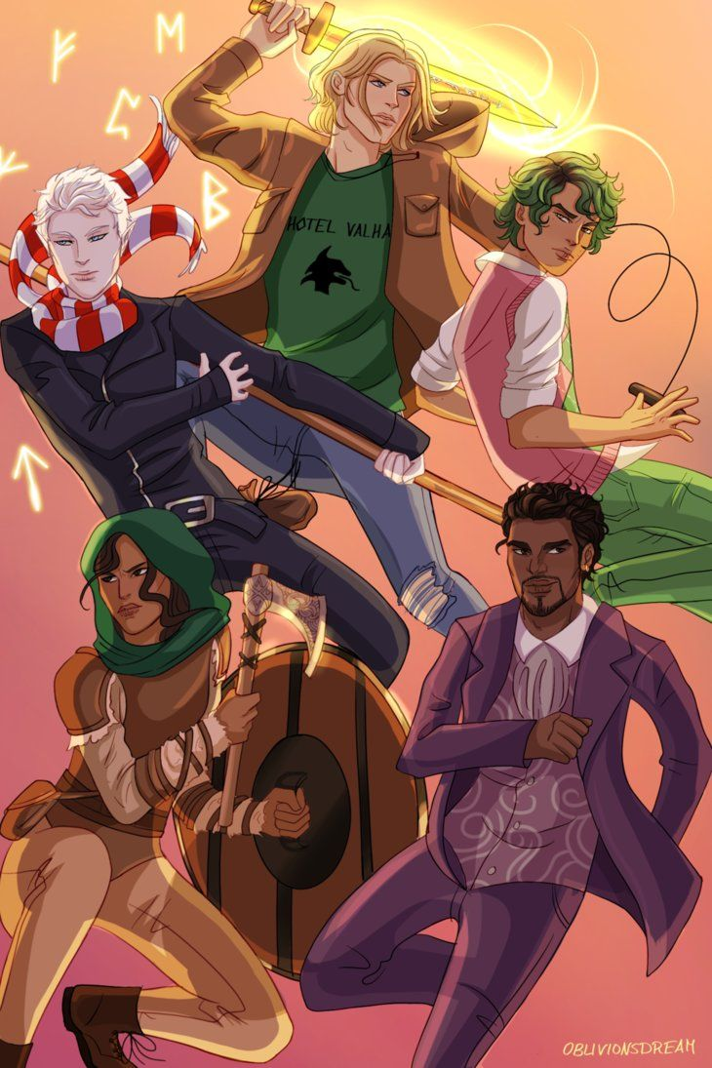
Here we can see the five main characters of Magnus Chase, Blitzen (bottom right) and Hearthstone (middle left) are Magnus’ two closest friends and still try to protect him, even after his death. Hearthstone has a really rather sad backstory, with Mr Alderman and the ring, which nicely contributes to the Perthro thing discussed in Sword of Summer. Samirah Al-Abbas (bottom left) is an interesting well-rounded character and the entire reason Magnus went to Valhalla. Alex Fierro (middle right) is Magnus’ significant other and he/she/they is gender-fluid in the story of Magnus Chase. Also, Alex’s garotte wire is easily the second coolest weapon is Magnus Chase. The best one, by far, is my boy, Sumerbrander or, as he prefers, Jack. Who doesn’t want a disco talking sword who likes to sing cringy pop songs. Also, our friends from Floor 19, Mallory Keen, Thomas Jefferson Junior and Halfborn Gunderson, totally deserve a shoutout. Finally, Magnus himself (top). He is a clever, skilled, sarcastic, dead and hilarious character and a perfect narrator for the series. One thing we can always count on from Rick is his funny character! With these characters by your side, why wouldn’t you want to read this trilogy?
Plot
Rick Riordan has written an amazing trilogy in the form of Magnus Chase, with a very complex plot line, so I will only list the base plot of the series. It begins with our protagonist, Magnus Chase, an orphan living on the streets of Boston who discovers he is the son of Frey, Norse god of spring, summer and healing. Suddenly, he dies fighting Surt, god of fire and king of flame and wind giants. Isn’t that wild? He then enters Valhalla and goes on three long journeys, rebinding Fenris Wolf, retrieving Thor’s Hammer, Mjolnir and rebinding Loki. I think the first two quests (or books) are incredibly gripping and well-written. However, the third book is much shorter and has a much less coherent storyline than the previous two. Rick Riordan was working on the Trials of Apollo at the time, but I still think the second half of Ship of the Dead is disappointing and rushed. The flyting with Loki is not a real flyting, the Whetstone of Bolverk is only used to distract a couple of farmers and they go out and literally admit Kvasir’s Mead was pointless, and so, by association was the Whetstone of Bolverk, the duel of Jork and every other bit in the entire second half of the book. They could have just sailed to Loki’s ship, said some corny message about the treasure and the power being the friends we made along the way and they still would have won. Also, every single character had crazy plot armour and nobody died. The first two and a half books were brilliant but the second half of the third book was anticlimactic, boring and cliche.
Thanks for reading my book report on the Magnus Chase trilogy by Rick Riordan.

By Felix. Year 7

