Tracking & Reporting
Guidance Notes for Parents
2022 - 2023





In this booklet, you will find answers to these questions:

- What is ‘tracking’ and why do we use it?
- What terms and grades are used in tracking reports?
- How will the school use tracking data?
- How can I help at home?
- Who should I contact if I have a query?

INTERIM

Guidance for Parents/Carers

What is ‘tracking’ and why do we use it?

We aim to provide you with information about the welfare and progress of your son/daughter throughout the year and tracking is just one way in which we do this. Other methods of keeping you informed are:

- Subject Review afternoons/evenings (once per year group per year).
- Academic Review evenings (once per year per year group) - a virtual meeting with the tutor to discuss general progress
- Contact from tutors and teachers throughout the year as the need arises.
- Insight, our parent portal – https://insight.worthinghigh.net/insight

This document aims to explain how tracking works and what you can do to help your son/daughter.

Tracking is designed to:
- Keep students, parents and carers informed about progress throughout the year – not just at the end of it.
- Be specific to individual students.
- Give students a greater sense of ownership of their own learning.
- Enable us to recognise the achievements of our youngsters and celebrate the vast majority of students who work hard day in, day out.
- Support students when they are struggling.

Explanation of the Terms and Codes Used in Tracking:

Agreed Target Grade (ATG) for KS4 (Years 10 and 11 – all subjects) and Year 9 (English, Maths and Science)

We use national data to generate target grades for your son/daughter at the start of their courses. This gives us an expected level of achievement which is based on students’ own prior attainment. We then refine this information, using our own knowledge of each student, to produce subject-specific targets. These are called the Agreed Target Grades (ATGs). ATGs for each subject are challenging targets and give us an appropriate benchmark against which we can assess pupil progress.

Tracking and reporting at KS3 (Years 7 and 8 – all subjects, Year 9 – all subjects except English, Maths and Science)

There are no grades at KS3, so we report student’s progress and effort across all subject areas. Current progress is based on working backwards from expected GCSE grades. Each subject maps out an expected level of skill and knowledge at each assessment point throughout KS3, this then gives a baseline to judge the amount of progress a student is making. This is bespoke to each subject area and levels of progress may vary between subjects. Teacher’s will make a judgement and report one of the following:

Outstanding progress - Students may exceed future KS4 targets
Good progress - Students may achieve their future KS4 targets
Below Expected progress - Students may not achieve their future KS4 targets

Effort is reported with a numerical value, as summarised below:

1 - Your child is working exceptionally well, their effort shown in class and for homework is consistently excellent.

2 - Your child is working well, their effort towards class and for homework is consistently good.

3 - Your child can work well but their effort does not always meet our expectations.

4 - Poor levels of effort shown, improvement is required immediately; the progress leader will arrange a meeting to discuss next steps.

If a child receives a 3 or 4 for effort, they will also receive a concern code, as summarised below:

a | Amount of absence from this lesson has affected academic performance.
b | Behaviour has been disruptive to learning.
c | Coursework/controlled tests below standard expected for target grade.
e | Has failed to prepare consistently for exam/controlled test.
f | Lacks focus and fails to concentrate fully thus affecting progress.
h | Homework not consistently completed to the required standard.
i | Classwork completed but homework tasks show insufficient detail and effort.
r | Lacks resilience (gives up easily when tasks are difficult). Needs to be more determined to achieve.
q | Quality of classwork is below standard expected for target level/grade.
t | Does not complete tasks fully/sufficiently to develop understanding.

These entries highlight one key area that needs to be addressed. Students deemed to be ‘below expected’ might have a concern for that subject indicated in this column. Tracking reports only identify one issue at a time; therefore, the most pressing issue is the one that teachers will record. If you have concerns about multiple issues, you are advised to contact the relevant subject teacher directly.

Current Grade (KS4 only):

Teachers supply this grade as an indication of how well a student is performing at the time of the tracking cycle. The current attainment grade will not necessarily match or exceed the ATG, especially at the beginning of KS4 (Year 9 for English, Maths and Science and Year 10 for all other subjects. (Remember: the ATG is a goal towards which students will be working throughout their courses.)

Students develop many of the skills required to reach higher grades throughout the course; to this effect, students can still be making good progress towards achieving their target grade even if they are not currently performing at that level. Thus, current attainment must be viewed in the context of the progress that your son/daughter is making overall.

Predicted Grade (KS4):

Teachers supply this grade as an indication of how well a student is progressing towards their ATG (for the end of KS4 courses at the end of Year 11) and gives a clear indication of the attainment the student is likely to achieveHow will the school use the tracking data?

The information supplied by subject teachers is analysed after each round of tracking by the Subject Leaders and Community Leaders. This enables them to identify students who are making good progress and acknowledge their achievements. It also enables them to identify students who are experiencing difficulties and put the appropriate support in place. The aim is to ensure that issues are identified and addressed quickly, thus enabling students to perform to the best of their abilities in final examinations.

How to help at home:

We are keen to involve parents in this process. Tracking reports will be sent home to you shortly after compilation and we hope you will be able to set time aside to review the report with your son/daughter. We hope you will join us in celebrating your child’s achievement when they are on target to meet their ATG. Equally important is the support you can offer your child to help tackle concerns that have been raised. If you would like further information about how to do this, or would like to discuss issues that have been raised by tracking, then please contact us (see below).

In some cases you may also be contacted by the relevant Progress Leader when there are significant issues to address, or notable successes to celebrate.

Thank you for taking the time to read this – please feel free to get in touch if you have any further questions, or would like to comment about how we report your son/daughter’s progress to you.
A Cook Deputy Headteacher

September 201

Contact Us:

If your query concerns: | Then please contact:
Progress in an individual subject… | The Subject Teacher then Subject Leader
Progress across all or many subjects… | Form Tutor then Progress Leader
Pastoral care or general well-being… | Form Tutor in the first instance
Comments about the school‘s assessment policies and procedures… | Mr A Cook, Deputy Headteacher

A Parent’s Guide Factsheet: GCSE 1-9

The main features of the GCSEs are:

- A grading scale of 9 to 1 will be used, with 9 being the top grade. This allows greater differentiation between students
- Assessment will be mainly by exam, with other types of assessment used only where they are needed to test essential skills.
- There will be new, more demanding content, which has been developed by government and the exam boards.
- Courses will be designed for two years of study - they will no longer be divided into different modules and students will take all their exams in one period at the end of their course.
- Exams can only be split into ‘foundation tier’ and ‘higher tier’ if one exam paper does not give all students the opportunity to show their knowledge and abilities. There are only two tiers in Maths, Science and Modern Foreign Language,
- Resit opportunities will only be available each November in English language and Maths

Comparison with older grading structure
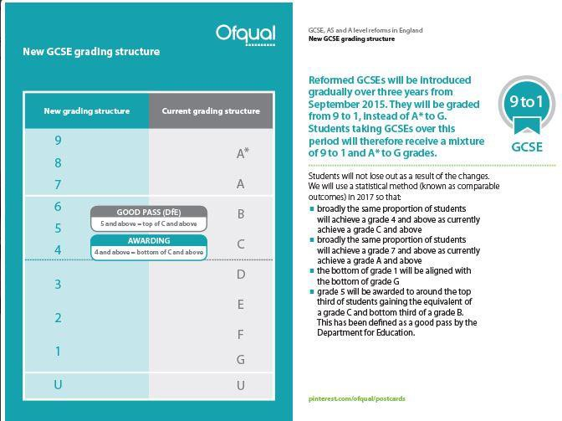

Broadly the same proportion of students now achieve a grade 4 and above as used to achieve a grade C and above. The grade 5 is be positioned in the top third of the marks for an old Grade C and bottom third of the marks for an old Grade B. This means it is harder to achieve than the old grade C.

The grade 5 is what will be required from sixth form colleges and universities as the benchmark for a strong pass. The school will sub-level the data to indicate whether students are working at the top end of the numerical scale, secure or just achieving the grade. This will be signified by a + sign for the top end, = for secure, and a – sign for just into the grade.

Grades used at Worthing High School

Key Stage 4 (Years 10 and 11) and Key Stage 3 (Years 7, 8 and 9) Agreed Target Grades:

9, 8, 7, 6, 5, 4, 3, 2, 1

KS4 (Years 10 and 11 – all subjects) and Year 9 (English, Maths and Science) - Current and Predicted Grades:

The following grades are used as a scale that begins at B3- and ends at 9+:

9+  9=  9-  8+  8=  8-  7+  7=  7-  6+  6=  6-  5+  5=  5- | 4+ B1+  4= B1=  4- B1-  3+ B2+  3= B2=  3- B2-  2+ B3+  2= B3=  2- B3-  1+  1=  1- B+ B= B-

(Grade) + | Indicates a student is working at the high end of the grade and has potential to move to the grade above.
(Grade) = | Indicates a student is working securely within the grade.
(Grade) - | Indicates a student is working at the low end of the grade and could drop back to the grade below.

BTECs/CNAT/VTCT:
Distinction * Distinction Merit
Pass Fail

