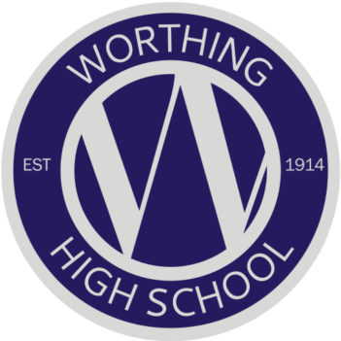
PRESS RELEASE
WORTHING HIGH SCHOOL
Excellent GCSE results for Worthing High School
Worthing High School students are celebrating yet another successful year of improved GCSE results. Our students have again made better than expected progress with improved attainment across the board, with 20% of all grades achieved at 7+.
Students achieved a record breaking 72% Level 4+ in English and Maths, with both English and Maths improving by over 10% from 2018.
82% achieved a Level 4+ in English and 75% a Level 4+ in Maths.
Worthing High School has maintained another strong year of Ebacc results, with 66% of students following this pathway. Other outstanding subject results include those in Design Technology, Food Preparation and Nutrition, Humanities subjects, Performing Arts, Sport and Science.
Outstanding individual performances include:
- Christina Lawrence – 8 x Grade 9, 2 x Grade 8, 1 x A*
- Jasmin Bailey – 5 x Grade 9, 4 x Grade 8, 1 x Grade 7
- Faran Lane – 3 x Grade 9, 5 x Grade 8, 1 x A*, 2 x Grade 7
- Joshua Farley – 4 x Grade 9, 5 x Grade 8, 1 x B, 1 x Grade 6
- Holly Young – 3 x Grade 9, 1 x Dist*, 3 x Grade 8, 3 x Grade 7, 1 x B
- Edie Odell – 1 x Grade 9, 6 x Grade 8, 1 x Grade 6, 1 x Grade 5, 1 x Grade 4
- Edward Palmer – 5 x Grade 8, 2 x Grade 7, 3 x Grade 6
This year’s 2019 results demonstrate the continued consolidation of improvements taking place at Worthing High School. As a school, we are delighted to see so many of our students achieving so much. Our students follow a broad and balanced curriculum across a range of academic and vocational subjects. Our drive for success is simple - high quality teaching, in a safe, friendly and caring environment, set alongside relentlessly high aspirations for academic attainment, and adherence to our Core Values; Community, Resilience, Respect, Integrity and Excellence.
Headteacher - Pan Panayiotou commented:
‘We are immensely proud of all of our Year 11 students and their academic achievements in their GCSEs. These positive results will provide them with the excellent foundations for their continued studies and training.
Their results are testament to their hard work and that of the dedicated staff at Worthing High school, who continually go above and beyond to support our students.
This reflects another successful year for Worthing High School and the very positive journey we are committed to for all our students in our community.
I am so very proud of what our students and staff have achieved and wish Class of 2019 every success in their futures. They are a credit to our families, our school and our local community.’

Contact details:

Karen Hayler, Business Development Manager, Worthing High School
01903 229275 email khayler@worthinghigh.net

